Systems Modeling to Improve River, Riparian, and Wetland Habitat Quality and Area

Authors
Ayman H. Alafifi¹ and David E. Rosenberg²
January 2020

¹Corresponding Author: Water Resources Engineer, Brown and Caldwell, Seattle, WA 98101. Phone: 435-881-0541. aalafifi@BrwnCald.com

²Associate Professor, Department of Civil and Environmental Engineering and Utah Water
Research Laboratory, Utah State University, Logan, UT, USA david.rosenberg@usu.edu

Requested citation: Alafifi, A. H., and Rosenberg, D. E. (2020). "Systems modeling to improve river, riparian, and wetland habitat quality and area." Environmental Modelling & Software, 126, 104643. http://www.sciencedirect.com/science/article/pii/S1364815218305309.

Systems Modeling to Improve River, Riparian, and Wetland Habitat Quality and Area

Abstract
Systems models to improve ecosystems often manage flows to meet minimum instream flow requirements or minimize deviations from a predefined flow regime. Here, we present a new systems optimization model that determines when, where, and how much to allocate scarce water, financial resources, and revegetation efforts to improve aquatic, floodplain, and wetland habitat areas and quality. This optimization is subject to constraints on water mass balance, vegetation growth, infrastructure capacities, and meeting existing agricultural and urban water demands. We followed a participatory approach to apply and validate our model to the Lower Bear River watershed, UT. Results show that increasing winter reservoir releases, minimizing spring spills, and planting native floodplain vegetation early in the growing season can increase suitable habitat area beyond managing water alone. Additional flow on the Little Bear River between August and December will most increase habitat area and quality compared to other locations.

Keywords: Systems models; River habitat quality; Reservoir operations; Floodplain revegetation; Bear River Utah; Watershed management; Web mapping application

Highlights
- A new ecological objective quantifies the suitable habitat areas of multiple aquatic, floodplain, and wetland habitat types
- A systems model shows when, where, and how much to allocate scarce water, financial resources, and revegetation efforts to improve habitat area and quality within a watershed
- Synergistic water and vegetation management can improve habitat for native fish, floodplain vegetation, and migratory birds.
- An open-access web map helps communicate opportunities to improve habitat area and quality to stakeholders.
Software and Data Availability
Name of software: | Watershed Area of Suitable Habitat (WASH) optimization model
Developers: | Ayman H. Alafifi and David E. Rosenberg
Contact: | aafifi@aggiemail.usu.edu
Year first available: | 2016
Hardware required: | A personal computer
Software required: | General Algebraic Modeling System software (GAMS) with non-linear global solver such as Branch-And-Reduce Optimization Navigator (BARON), MS Excel 2016, R 3.3.0, and a web browser
Software availability: | All source code, input data, post-processing file, and documentation are available on Alafifi (2017). The application of WASH to the Lower Bear River, Utah for one year (2003) is displayed on an open-access web map at: https://www.WASHmap.usu.edu. The source code is available on GitHub at: https://github.com/ayman510/WASH
Cost: | The source code is released under the BSD 3-Clause, which allows for reuse of the code.

Systems Modeling to Improve River, Riparian, and Wetland Habitat Quality and Area

- Introduction
Rivers and their riparian and wetland areas are managed to supply domestic and agricultural water users, generate hydropower, reduce flood damages, and support habitat for flora and fauna (Bernhardt et al., 2005). Although river managers often prioritize human beneficial uses, flow management can also improve habitat (Jager and Smith, 2008; Tharme, 2003). Improving river habitat requires defining ecological objectives and determining the timing, magnitude, and locations of reservoir releases, diversions, and restoration efforts to advance the objectives.
Determining timings, magnitudes, and locations of management efforts often requires navigating a complex set of ecological, hydrological, modeling, and stakeholder considerations. First, managers must identify and locate the aquatic, floodplain, and wetland habitat areas in the basin that need improvement. Second, they should select indicator species from among the numerous species available in each habitat whose habitat needs should be satisfied or improved. Habitat needs can encompass flow, vegetation, and other conditions. Third, managers may use models to mathematically quantify each indicator species’ response to habitat conditions. And finally, managers must collaborate with watershed stakeholders to identify when, where, and how to allocate water, financial resources, revegetation efforts to improve habitat while meeting other water uses in the basin (Barbour et al., 2016).
Some quantification and modeling approaches, such as the natural flow paradigm, estimate species hydrologic requirements to mimic important timing, duration, magnitude, and frequency features of the natural flow regime (Poff et al., 1997). These approaches assume that historical natural flows are known and adequate to support ecosystem functions (Baron et al., 2002). Other approaches, such as habitat suitability indices (HSI; U.S. Fish and Wildlife Service 1981) and derivatives (Hickey and Fields, 2013), use empirical relationships to describe the suitability of habitat to support the survival and productivity of a single species. Suitability is a function of single or multiple habitat attributes such as instream water depth, water temperature, substrate, or flow duration. HSI values range from 0 (poor) to 1 (excellent) (Hemker et al., 2008; Hooper, 2010; Pinto et al., 2009). The Weighted Usable Area (WUA) method multiplies the habitat suitability index by the reach surface area and divides by reach length (Stalnaker, 1995). WUA can be used to describe habitat quality for a particular species at a specific site and time under prior or specified flow scenario (Garcia-Rodriguez et al., 2008; Moir et al., 2005; Souchon and Capra, 2004). These approaches cannot determine whether a proposed flow regime is feasible nor do they recommend locations, timings, or magnitudes of water allocations or other restoration efforts across a watershed to improve multiple habitat types and species.
Water resources systems models can include multiple ecosystem assets as part of a connected network of reservoir, river, tributary, diversion, demand, and return flow components and can determine the feasibility of proposed flow regimes. Many models include habitat considerations as constraints, such as to meet a minimum required instream flow (see, for example, Cioffi and Gallerano, 2012; Harman and Stewardson, 2005; Porse et al., 2015; Ryu et al., 2003). In other cases, a suitability index is maximized or minimized as a single objective or tradeoff with water delivery, hydropower generation, or other objectives (Null et al., 2014; Simonović and Nirupama, 2005; Yang, 2011). Alternatively, models try to minimize deviations from a pre-defined target value. For example, Higgins et al. (2011) developed a heuristic nonlinear integer optimization model to minimize the difference between managed and natural flow regimes in the Murray River, Australia. Steinschneider et al. (2014) used linear programming to minimize the deviation between model recommended reservoir releases and estimated natural flows in the Connecticut River basin. Szemis et al. (2012, 2014) developed a heuristic ant colony nonlinear model for the Murray River to minimize the inverse of an ecological index plus constraint violations. Minimizing deviations from an ecosystem target poses challenges because managers must define the target, such as natural flow regime or species-required flow (Barbour et al., 2016). Further, indices may not have physical meaning and are difficult to measure, validate, and communicate. Also, changes in the deviation objective depend on how close the current system state is to the ecological target. Managers who minimize indices or deviations from targets find it difficult to identify opportunities to improve habitat and compare potential improvements across watershed sites and time. Additionally, all these models focus solely on managing water to improve flow-based habitat objectives.
This paper develops the Watershed Area of Suitable Habitat (WASH) systems model, which formulates and embeds a suitable habitat area metric as an ecological objective to maximize. Suitable habitat area represents the combination of habitat quality and area, is based on flow and vegetation conditions that support and enhance the life needs of priority species, and is measured as the sum of monthly suitable aquatic, floodplain, and wetland habitat areas across the watershed for each priority species. This summation means suitable areas are specific to the species and species life stage and can vary though time. WASH synergistically recommends water allocation and revegetation efforts to improve suitable habitat area for priority species. This modeling approach allows managers to (i) compare ecological measures across sites; (ii) identify where and when to apply scarce water, money, and planting efforts to most improve habitat quality and area; and (iii) involve stakeholders to help define indicator species, view, and validate results. Section 2 introduces the study area for the Lower Bear River, Utah. Section 3 describes the model formulation and system components. The remaining sections present results, implications to manage water and vegetation, and conclusions.
- Study Area
The Lower Bear River (LBR) study is part of the longer 491-mile Bear River that starts in Utah, flows north through Wyoming and Idaho, then returns south to Utah. The study area includes the Bear River from the Utah-Idaho state line to the river’s terminus at the Great Salt Lake and tributaries (Figure 1). The Utah Division of Water Resources (2004) estimates that approximately 60% of LBR flow comes from snowmelt runoff in April, May, and June. The river and its tributaries irrigate over 300,000 acres of agricultural land and supply water to numerous cities and communities, as well as run-of-river hydroelectric plants (UDWR, 2004; UDWRe, 2000). The river is central to a development debate for several growing areas within and outside the basin such as Cache and Box Elder Counties, and the Wasatch Front metropolitan region to the south (UDWR, 2004; UDWRe, 2000).
The LBR is also vital to maintaining critical wildlife habitat for many native and threatened fish, riparian plants, and migratory bird species (Bio-West, 2015). Intensive urbanization, water development, fish barriers, and grazing for over a century have disturbed flow regimes for native and game fish species, reduced floodplain connectivity, and altered native plant community composition (Bear River CAP, 2008; Bio-West, 2015). At the river’s terminus at the Great Salt Lake, the U.S. Fish and Wildlife Service (FWS) manages the 300 km² Bear River Migratory Bird Refuge (hereafter the Bird Refuge). Here, impounded wetlands provide feeding, resting, and breeding grounds for over 250 globally significant populations of migratory birds (Alminagorta et al., 2016).
According to western U.S. prior appropriation doctrine and Utah state water law, the Bird Refuge holds a more recent water right that is junior to more senior upstream agricultural users (Downard et al., 2014). Thus, senior irrigators take their entire water rights before the Refuge receives any water. Most other land in the LBR is privately owned and few formal or legal mechanisms exist to provide water to improve fish, riparian plant, and migratory bird habitats (Lane and Rosenberg, 2018). The Nature Conservancy, Trout Unlimited, landowners, and local, state, and federal agencies have identified low flows as a major threat to fish populations, riparian plants, and migratory birds in the watershed (Bear River CAP, 2008). The current, highly disturbed regimes makes the natural (without development) regime unknown and likely extremely difficult to return to. Thus, systems modeling can help managers identify a synergistic water volume, timing, location and planting area efforts to improve ecosystem health for priority aquatic, floodplain, and wetland species over current conditions.

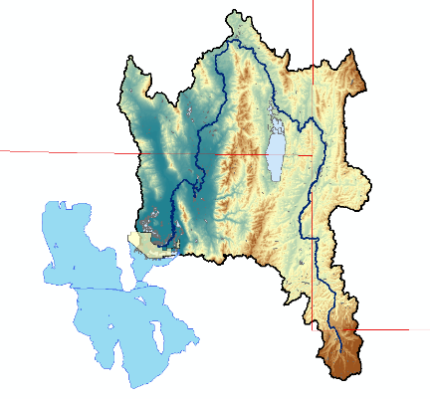
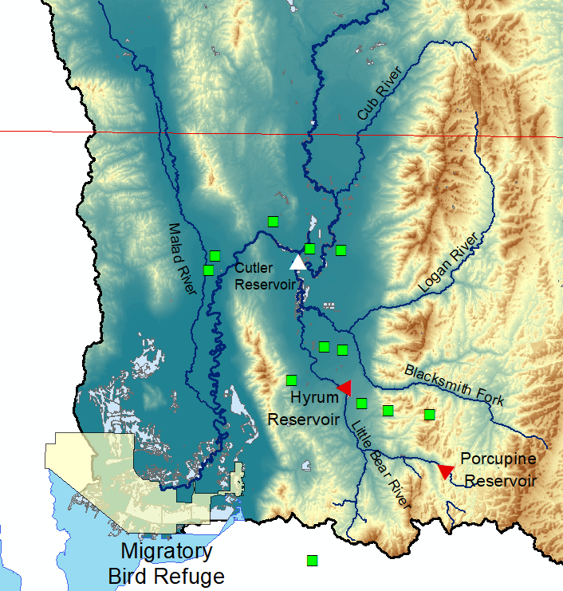
Reservoirs
Demand Sites
Bird Refuge
State Lines
Utah
Idaho
Wyoming
Utah
The Great Salt Lake

Figure 1: The Lower Bear River, Utah including major tributaries, demand sites, and reservoirs

- Model Development
Improving river habitat quality and area requires a collective effort among researchers, managers, and stakeholders to identify habitat types, priority sites, indicator species, habitat characteristics, suitability of habitat for species, and the network of water system components. Here, we demonstrate a participatory approach to develop a systems model that can recommend scarce water, financial resources, and revegetation efforts to improve habitat area and quality.
We began by engaging with the managers, organizations, and stakeholders working to implement the Bear River Conservation Action Plan (Bear River CAP, 2008). Working with these individuals and organizations, we selected key indicator species, collected model input data, and formulated model scenarios. Below we describe the general model formulation of decision variables, objective function, and constraints. In the formulation, capitalized terms represent variables, lower case indicates parameters and model inputs, and lettered subscripts denote indices for space, time, species, and habitat types (bottom of Figure 2).
  - Select indicator species
The presence and abundance of indicator species is a strong signal of ecosystem health and response to alterations in flow regimes (Carignan and Villard, 2002). We identified key native and game fish, riparian plants, and wetland migratory bird species in the LBR watershed based on their abundance in the watershed and sensitivity to changes in flow regimes. For each species, we defined suitable ranges of habitat attributes such as water depth and flood recurrence in each month and for each life stage (Table 1). We derived habitat attribute ranges from literature, empirical studies, and other models and verified them with project stakeholders.
Fish spawning, seed recruitment, and migratory bird feeding, nesting, and breeding occur during particular months. We selected a monthly time step (t) for WASH because watershed managers manage flows and plan revegetation efforts at monthly intervals.

Table 1. Habitat indicator components by habitat type, species, species life stage, seasons, and ecosystem function.
Habitat | Indicator Species | Life Stage | Function (timing) | Habitat Attributes | Suitable Range of Habitat Attribute | Affected Area | Data Source(s)
Aquatic | Bonneville cutthroat trout (Onchorynchus clarki utah) | Adult | Native spawning (Sep. – Mar.) | Water depth (m) | 0.30 - 0.75 | Channel surface area | Hickman and Raleigh (1982), Braithwaite (2011), Gosse et al. (1977) and Gosse (1981)
Aquatic | Bonneville cutthroat trout (Onchorynchus clarki utah) | Fry | Native maturing (Apr. – Aug.) | Water depth (m) | 0.10 - 0.45 | Channel surface area
Aquatic | Brown trout (Salmo trytta) | Adult | Game fish spawning  (Sep. – Mar) | Water depth (m) | 0.10 - 0.80 | Channel surface area
Aquatic | Brown trout (Salmo trytta) | Fry | Game fish maturing  (Apr. – Aug.) | Water depth (m) | 0.10 - 0.50m | Channel surface area
Floodplain | Cottonwoods (Populus fremontii) | Seed germination& dispersal | Native recruitment  (Apr. – Aug) | Overbank flood recurrence | > Bankfull flow | Floodplain area | Meier and Hauer (2010) Mahoney and Rood (1998)
Wetland | Black-necked stilt (Himantopus mexicanus) | Adult | Feeding, resting, and breeding  (Apr. – Sep.) | Water depth (m) | 0.15– 0.25m | Impounded wetland area | Alminagorta et al. (2016)
 |  |  |  | Invasive plant cover (%) | < 10% | Impounded wetland area | Alminagorta et al. (2016)
Wetland | American avocet (Recurvirostra Americana) | Adult | Feeding, resting, and breeding (Mar. – Oct.) | Water depth (m) | 0.35- 0.45m | Impounded wetland area | Alminagorta et al. (2016)
 |  |  |  | Invasive plant cover (%) | < 10% | Impounded wetland area | Alminagorta et al. (2016)
Wetland | Tundra swan (Cygnus columbianus) | Adult | Feeding and resting  (Nov.– Mar.) | Water depth (m) | > 0.55m | Impounded wetland area | Alminagorta et al. (2016)
 |  |  |  | Invasive plant cover (%) | < 10% | Impounded wetland area | Alminagorta et al. (2016)
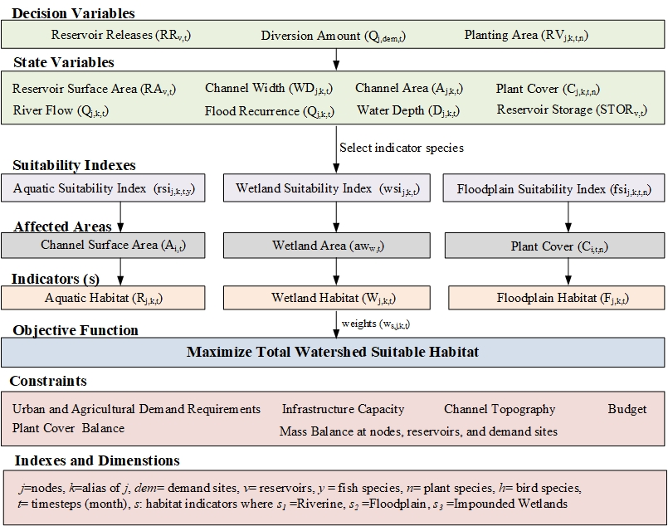
Figure 2. The WASH model connects decision variables, state variables, parameters, and suitability indices to an objective function measured as habitat area. Physical, management, and plant constraints limit decisions

  - Decision Variables
Decision variables include water management and planting area actions. To improve habitat quality, managers can adjust reservoir releases RR_{v,t} [million cubic meters per month, Mm³] at reservoir v in month t. They also control diversion volumes Q_{j,dem,t} [Mm³/month] from the river at node j to demand sites dem in month t to satisfy urban and agricultural demand. Managers can also plant RV_{j,k,t,n} [Mm²] the floodplain adjacent to the river reach from node j to node k during month t by seeding or planting species n. These variables control a group of state variables that include reservoir storage volume STOR_{v,t} [Mm³], reservoir surface area RA_{v,t} [Mm²], river flow Q_{j,k,t} [Mm³/month] from node j to node k in month t, river water depth D_{j,k,t} [m/month], channel surface area A_{j,k,t,} [Mm²], channel width WD_{j,k,t} [m], and floodplain plant cover C_{j,k,t,n} [Mm²].
  - Objective Function
The objective function maximizes the weighted sum of the suitable areas of aquatic [IND_{aquatic,j,k,t}], floodplain [IND_{floodplain,j,k,t}], and wetland [IND_{wetland,j,k,t}] habitats [Mm²] across reaches j to k and time (month t) where ${wght}_{s,j,k,t}$ are stakeholder-decided weights for habitat indictor s in reach j to k at month t. Weight values range from 0 (not important) to 1 (important).
$Max Z=\sum_{s,j,k,t}{{wght}_{s,j,k,t} ∙ {IND}_{s,j,k,t}}$ [1]
The value of each habitat indicator is the product of a suitability index representing habitat quality and an affected area. Using the habitat suitability ranges in Table 1, we designed suitability indices (SIs) [unitless] for aquatic, floodplain, and impounded wetland habitats as functions of hydrologic and ecological habitat attributes that influence priority species survival and abundance, such as water depth, flood recurrence, and plant cover. Functions defining SIs are specific to the reach, species, species life stage, and habitat attribute. The SIs approach 1 (excellent conditions) when values for the habitat attribute support densities for the priority species that exceed a certain threshold. In contrast, SIs approach 0 (poor conditions) when the density of a priority species is below a threshold (Roloff and Kernohan, 1999). SIs are constructed using empirical data, literature, and expert opinion.
Affected areas are the reach-specific habitat areas in the watershed at which each suitability index applies (Figure 2). Affected areas in these reaches are functions of flow and plant cover habitat attributes.
The summation of suitable areas across habitat types and species life stages follows Szemis et. al (2012; 2014) and assumes species life stages have independent ranges of flow- and vegetation attributes that define their suitable habitat. Suitable areas vary dynamically in time and summing suitable areas across time allows the model to consider compensatory effects across life stages (e.g., moderate habitat for fry maturing in summer months may still lead to excellent habitat for adults to spawn in winter). This summation differs from other methods that use multiplication, geometric average, or lowest values to aggregate multiple suitability indices into a composite index (Ahmadi-Nedushan et al., 2006). These aggregation methods assume poor habitat for one species or life stage in one location leads to poor habitat in subsequent life stages. The WASH metric instead seeks to identify where and when to improve habitat for particular species and life stages.
    - Aquatic Habitat
Managers can improve fish habitat in the LBR by improving flow regimes that shape physical habitat health and determine biotic composition of riverine species (Bunn and Arthington, 2002). Here, we use water depth and temperature as two primary abiotic factors that define aquatic habitat quality and suitability for fish (Jackson et al., 2001). We designed water depth suitability curves and adjusted them to fish species tolerance for water temperature.
The Bonneville cutthroat trout (BCT; Oncorhynchus clarki utah) is a critical native fish species in the Blacksmith Fork and Little Bear rivers, two Bear River tributaries, and is the target of many restoration efforts because of declining numbers in recent decades (Bio-West, 2015). Brown trout (Salmo trytta) is a popular non-native game fish species that has high tolerance to low summer flows, warmer temperatures, and parasites causing whirling disease compared to other members of the trout family (UtahFishingInfo Website, 2016).
The lower elevation Bear River main stem has warmer summer water temperatures that reach 26º C. The higher elevation Little Bear and Blacksmith Fork rivers have cooler water temperatures that do not exceed 22.5º C (Watershed Sciences, 2007). Johnstone and Rahel (2003) report that water temperature at or above 25º C could be lethal for BCT, while Raleigh et al. (1984) reported that brown trout can tolerate water temperature up to 27.2º C. Currently, BCT is only abundant in the headwaters of the Blacksmith and Little Bear rivers (DeRito, pers. comm., 2016). Thus, we assigned BCT as the indicator fish species in the headwater reaches and brown trout in the remaining reaches.
We developed the aquatic suitability index (rsi; unitless) as a function of water depth $D_{j,k,t} .$ The rsi curves vary between 0 at water depths in LBR reaches where empirical studies found no fish to 1 at water depths where fish (or redd counts) were abundant. The corresponding water depth ranges for BCT were obtained from a 2-year study in the nearby Strawberry River by Braithwaite (2011) and for brown trout from Gosse et al. (1977) and Gosse (1981) on the Logan and Provo rivers in northern Utah. Water depth ranges were also verified by the project stakeholders. For brown trout, we assigned a poor suitability index value of 0 at 10 cm water depth because brown trout can tolerate very shallow depths (Raleigh et al., 1984). We used Boltzmann and exponential decay functions to specify the shapes of suitability index curves for BCT and brown trout (Figure 3, top and middle) based on similar FWS HSI curves for water depth (Hickman and Raleigh, 1982; Raleigh et al., 1984).
The aquatic habitat indicator is the product of rsi for each reach (j,k), month (t) and fish species (y) and the corresponding channel surface area (Eq. 2). With multiple fish species (y), we multiply suitability indices together to emphasize the concurrent need for suitable water depths for all species at the same time and location.
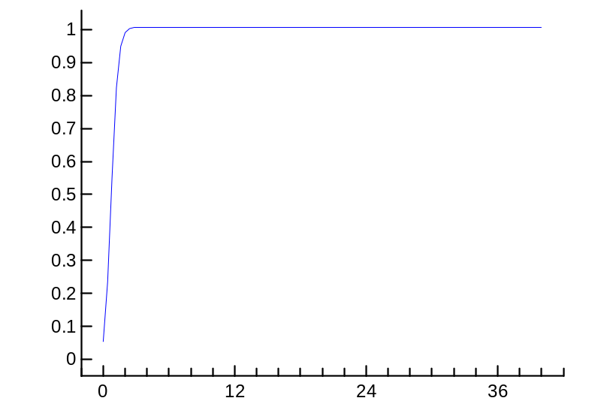
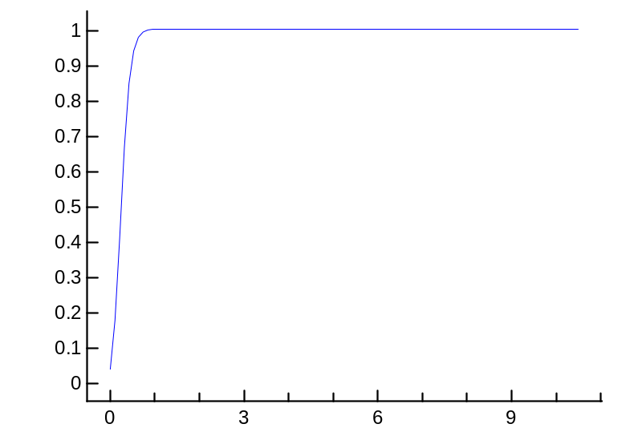
${IND}_{aquatic,j,k,t}=\prod_{y}{{rsi}_{j,k,t,y}\left(D_{j,k,t}\right)} ∙{ A}_{j,k,t} , ∀ j,k,t$ [2]

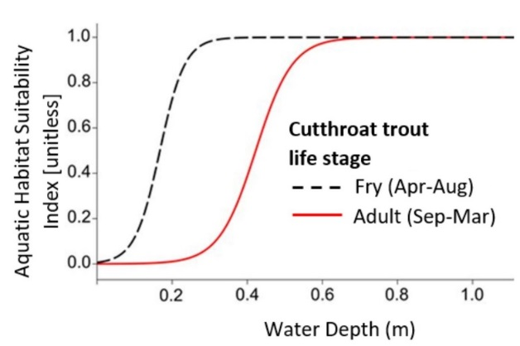
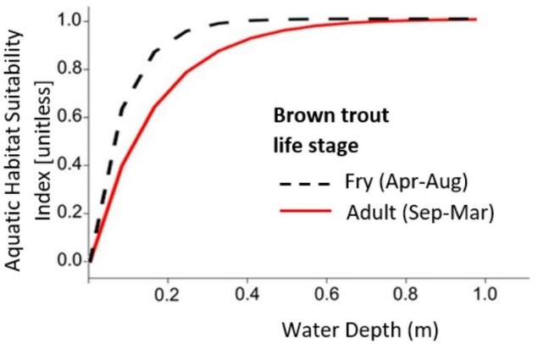
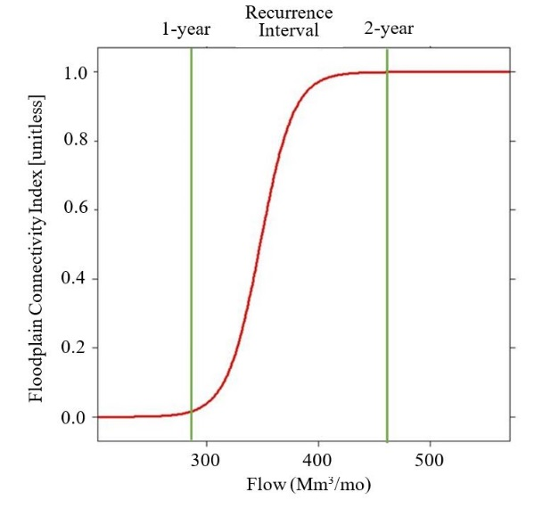
Figure 3. Habitat Suitability Index values for Bonneville cutthroat trout (top) brown trout (middle) and cottonwood recruitment (bottom).

    - Floodplain Habitat
Floodplain areas are adjacent to streams and are periodically inundated with water. Seasonally high water levels in these areas inundate riparian plant roots and keep soil moist (Meier and Hauer, 2010). The lateral connectivity between the river channel and its floodplain area is a primary factor shaping plant community composition, abundance, and survival (Merritt et al., 2010; Poff et al., 1997; Rivaes et al., 2013; Rood et al., 2005). Managers can improve floodplain connectivity by concurrently managing flows and plants cover. In connected floodplains, plant recruitment and seed germination coincide with overbank flood events that occur when discharge exceeds the bankfull flood level (Meier and Hauer, 2010; Yarnell et al., 2010). This level is defined as the visible break in slope between the un-vegetated bank and the adjacent vegetated floodplain surface (Li et al., 2015; Parker et al., 2007). Bankfull discharge is often associated with the 1.5 year flood recurrence interval (Kilpatrick and Barnes, 1964; NOAA, 2015; Rosgen, 1994). Therefore, to restore lateral connectivity, managers need to determine the proximity of priority floodplain plants to riverbanks and manage streamflow to exceed bankfull discharge and inundate target plants during their seed germination season.
We selected cottonwood trees (Populus fremontii) as an indicator native plant species in the LBR because it predominates in basin floodplains and provides shade, food, and habitat for mammals, birds, and insects (Bio-West, 2015). Cottonwoods release seeds just after peak flows in snowmelt-driven rivers (Bhattacharjee et al., 2006; Mahoney and Rood, 1998). Thus, lateral connectivity between the channel and floodplains is most important between April and June for successful seed dispersal and through August for the continued soil moisture needed to establish dispersed seeds (Bhattacharjee et al., 2008; Mahoney and Rood, 1998). Cottonwood trees grow adjacent to river channels and are likely to be inundated by flow magnitudes over bankfull flow (1.5-year flood recurrence value). Therefore, we designed the floodplain suitability index (fsi; unitless) as a function of streamflow $Q_{j,k,t}$. The index curves transition from 0 (poor lateral connectivity), when flow is at or below the 1-year recurrence value, to 1 (excellent connectivity) when the instream flow equals or exceeds the 2-year recurrence flow (Figure 3, bottom). The 1- and 2-year recurrence flow thresholds at different reaches in the basin are determined from historical flow records using the Log Pearson Type III distribution with mean and standard deviation of the log-transformed annual flow series. We measured initial existing cottonwood tree cover alongside every reach from NAIP Imagery.
The floodplain connectivity indicator is calculated by multiplying fsi for reach, month, and riparian plant species by the area of plant cover (C) and then summing the values for each plant species n [eq. 3]. The summation across plant species in eq. [3] allows one or multiple plant species to coexist at different lateral distances from the riverbank and these different lateral distances require different flood magnitudes to establish connectivity. Here, we only use cottonwood trees, which live adjacent to river banks and require flood recurrence of 2-year for lateral connectivity (Richter and Richter, 2000). Other riparian trees such as Pacific willow (Salix lasiandra) live further upslope in the floodplain and require a higher flood frequency interval for lateral connectivity (Dettenmaier and Howe, 2015; Rood et al., 2003).

${IND}_{floodplains,j,k,t}=\sum_{n}{{fci}_{j,k,t,n}{(Q}_{j,k,t}) ∙ C_{j,k,t,n}}$ $∀ j,k,t$ [3]

    - Impounded Wetlands
Wetlands are recognized as one of the most productive ecosystems for a variety of wildlife species, particularly water birds (Nikouei et al., 2012). Impounded wetlands have dikes, gates, weirs, canals, or other hydraulic structures that allow managers to control flows into and out of wetlands. The Bird Refuge comprises 25 impounded wetland units that draw water from the Bear River (Downard et al., 2014). Maintaining wetland ecological services at the Bird Refuge requires managing habitat y for the different water depths and plant cover that different bird species need to feed, nest, rest, and breed (Downard and Endter-Wada, 2013; Faulkner et al., 2010; Rogers and Ralph, 2011).
Prior work by Alminagorta et al. (2016) developed a composite Usable Area for Wetland (WU) metric for the Bird Refuge (measured in km²). The study embedded the metric in a systems model and maximized the wetland surface area with suitable habitat for Black-necked stilt, American avocet, and Tundra swan (Table 1). These three priority bird species were selected because they use a range of shallow, medium, and deep water habitat that encompass depths used by 20 other priority bird species at the Refuge.
We related the WU and river flow outputs of Alminagorta et al. (2016) work at the Bird Refuge by running Alminagorta et al.’s model to obtain the monthly WU values from the annual water availability scenarios between 1992 to 2011. Next, we divided monthly WU areas by the total Refuge area to get a monthly wetland suitability index value. Then we developed monthly relationships between the suitaibilty index values and monthly river flows measured just upstream of the Bird Refuge at the Corinne, UT USGS station (one example shown in Appendix A, Figure A1).
The impounded wetland indicator is calculated by multiplying a wsi index (as a function of streamflow) by the total wetland surface area aw [Mm²]. In Eq. [4], the wsi defines an aggregate suitability index for multiple wetland bird species.
${IND}_{wetlands,j,k,t}= {wsi}_{j,k,t}\left(Q_{j,k,t}\right) ∙ {aw}_{j,k,t}, ∀ j,k, t$ [4]

    - Constraints
Reservoir releases, diversions, planting, and other decisions are bound by physical, infrastructure, and management constraints (Appendix B, eqs. 5-18). Physical constraints include low-order, finite-difference approximation to conservation of water mass balance at each reservoir, node, and demand site. They also include equations to constrain plant cover growth over time and define channel topography. Infrastructure constraints place minimum and maximum limits on reservoir and diversion canals capacity. Management constraints include urban and agricultural demand requirements and available budget to plant floodplain vegetation. Nonlinear objective and constraint functions in the WASH formulation are all continuous and smooth to avoid numerical difficulties in the optimization.

  - Model Input Data
The WASH model requires hydrologic, ecological, topological, and management data (Appendix A, Table A1). We collected the required data from sources including the Utah Division of Water Resources (DWRe) water supply/demand simulation model for the Lower Bear River (Adams et al., 1992). Between August 2012 and November 2016, we also established two monitoring sites on the Bear River mainstem and one site on the Cub River to collect and ground truth hydrologic and ecological data. We assumed a budget of $650,000 to plant floodplain areas with cottonwoods based on a Cache County Water Masterplan estimated budget for future ecosystem projects (JUB Engineers, 2013). This budgeting assumes there is no cost to change reservoir releases or diversion flows which infrastructure constraints require to stay within existing infrastructure capacities. Processed hydrologic and ecological data are available at the Bear River Fellows website (http://bearriverfellows.usu.edu). WASH model input data and code are available at the WASH GitHub repository (Alafifi, 2017).

  - Model Scenarios
We implemented the model on a monthly time step for scenarios that test the effects of simulation vs. optimization, inflow hydrology, and length of modeled time period (Table 2).
Table 2. WASH model scenarios
No. | Scenario | Time | Purpose
1a. | Base case - optimization | One calendar year (2003) | Compare habitat area and quality for model recommended management practices to simulated practices. Run for a typical water year, based on monthly headflows observed over the last 15 years. Simulation was performed by fixing flows on all river segments to observed historical gaged values.
1b. | Base case- simulation | One calendar year (2003)
2. | Wetter year | One calendar year (2005) | Examine model behavior and response to increases and decreases in headflows.
3. | Dryer year | One calendar year (2004)
4. | Multi-year | 5 calendar years (2003-2007) | Examine the effects of annual flow variability on model results

  - Model Implementation
We segmented the Bear River and its main tributaries into a network of 43 nodes and 56 links, with 3 reservoirs, 12 municipal and agricultural demand sites, and 26 environmental sites where species of concern live (Figure B1; Appendix B). We ran the model with the same weight value of 1 for all indicators to equally favor all locations, species, and months.
We coded the WASH model [equations 1–17] using the General Algebraic Modeling System software (GAMS; Hozlar, 1990) and solved the model using the non-linear global solver Branch-And-Reduce Optimization Navigator (BARON; Sahinidis, 1996). The GAMS code uses GDX (GAMS Data Exchange format) to read all input data from an MS Excel spreadsheet and pass data to the model. The 1-year implementation of the model for the Lower Bear River system has approximately 27,000 variables and 5,300 equations and takes 2 hours and 15 minutes to find a global optimal solution on a Dell XPS Windows10 64-bit computer.
  - Model Outputs and Visualization
WASH results include recommended flows, reservoir releases, storage volumes, planted area, vegetation cover, and temporal and spatial variations of suitable aquatic, floodplain, and impounded wetland habitat area. We used Excel, R, and ArcGIS Online to post-process and display model results in an open-access, interactive web map (http://WASHmap.usu.edu). With the web map, users can compare modeled and simulated results, add base maps and data layers, and customize the tool. The WASH map displays results in US Customary Units to communicate better with local stakeholders. All WASH model input data, code, and post-processing files are available at the WASH GitHub repository (Alafifi, 2017).

Results
The model run that simulated 2003 flows shows that modeled suitable aquatic, floodplain, and wetland habitat area in the watershed is far from the maximum habitat area (Figure 4, hashed bars compared to dashed lines). In contrast, WASH recommended water allocations and planting of native vegetation have potential to increase the overall suitable habitat area by 25,000 acres (Figure 4, solid compared to hashed bars). This overall increase is achieved with up to 3-, 10-, and 7-fold increases over 2003 modeled historical conditions of aquatic suitable area in all months, floodplain suitable areas in April to August, and wetland suitable areas at the Bird Refuge from June to August (Figure 6). The model identifies increases in habitat in every month for all fish species life stages with the largest increases in May, June, and November. The largest floodplain habitat increases for plants occur in July and August on Bear River reaches above Cutler reservoir. These suitable areas approach 53%, 3%, and 40% of the total aquatic, floodplain, and wetland habitat areas in the basin.
Figure 4. Monthly suitable aquatic, floodplain, and wetland habitat areas in the Bear River watershed compared to total available areas (dashed, horizontal lines)

The WASH model improves suitable habitat area by recommending monthly reservoir release, storage, and floodplain planting operations. WASH recommends increasing Dec. to Mar. releases at Hyrum Reservoir which creates additional empty storage in winter and spring that permits reducing late spring (Apr. to May) spills from Hyrum and Porcupine reservoirs (Figure 5). This recommended release pattern allows a small increase in late Fall and winter base flows that support brown trout spawning in late fall and maintains the eggs in gravel redds until they hatch in spring. Releasing more water in early spring supports floodplain connectivity and helps to mitigate flooding impacts. The gradual release of water from reservoirs also protects trout eggs from winter and spring flood events that could scour or kill incubated eggs and newly emerged fry (George et al., 2015) and could be harmful to cottonwood seedlings. The model also recommends planting cottonwoods starting in March that increase vegetation cover and floodplain suitable area; increased suitable floodplain area occurs even with declining or stagnant flows in several reaches (Figure 6). The model increases habitat area while continuing to meet urban and agricultural water uses at all demand sites during all months.
Although wetland suitable area at the Bird Refuge increases to only 40% of the total suitable area, improvements occur during critical summer months when Bear River flows at Corrine

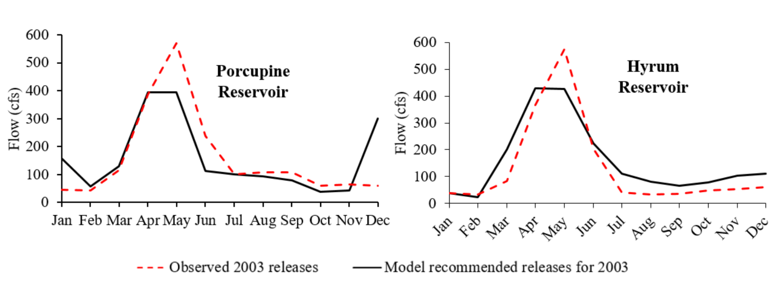
Figure 5. Comparison between model recommended and current reservoir releases for 2003 for (right) Hyrum and (left) Porcupines reservoirs
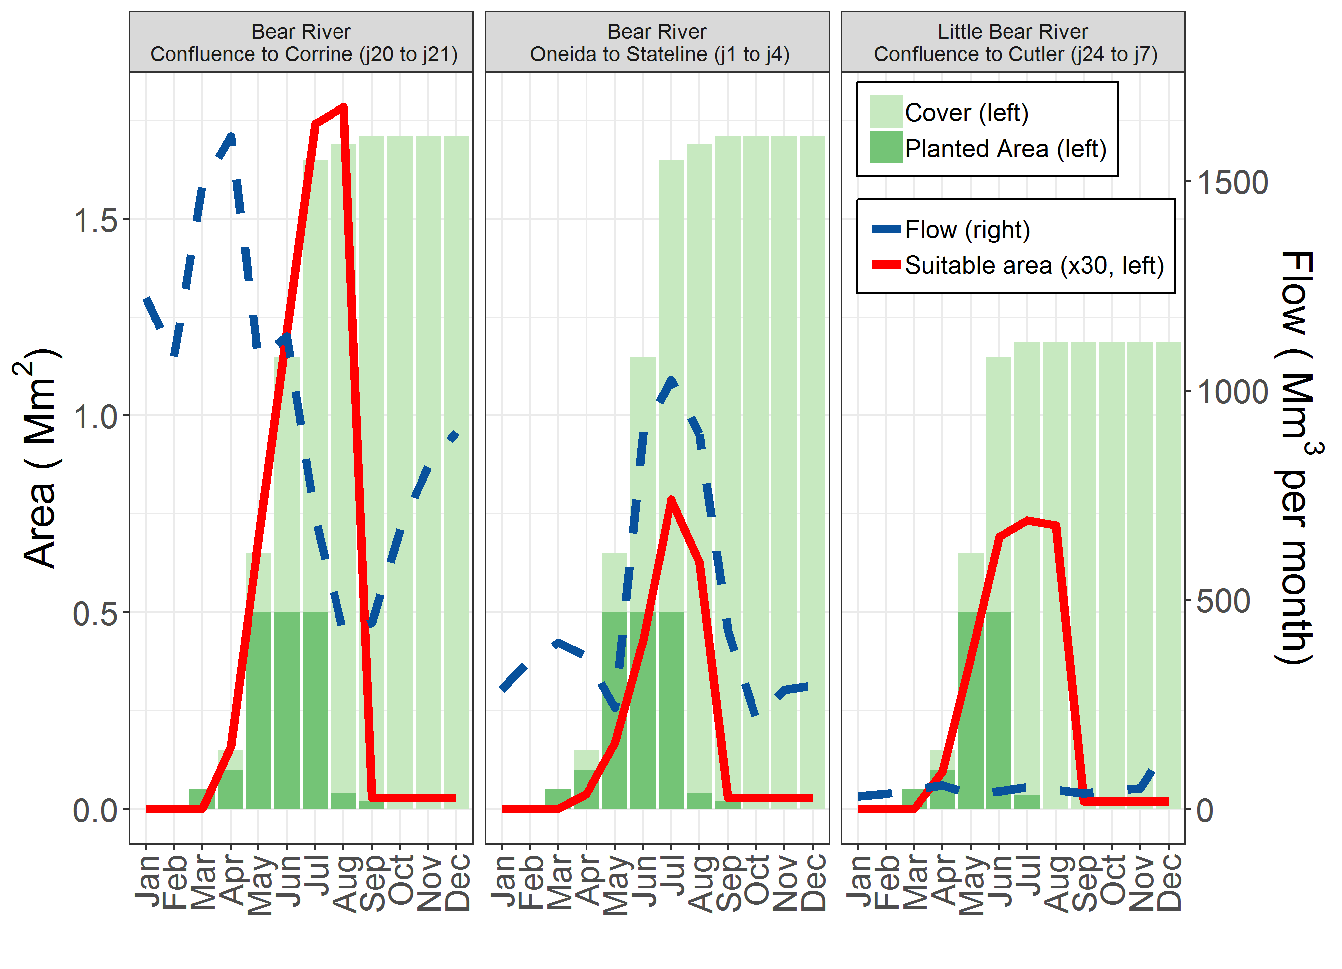
Figure 6. Vegetation cover and planting area versus flow and floodplain suitable area for three representative reaches

typically did not satisfy the Bird Refuge’s junior water rights (Figure 7). Overall, the model recommended habitat area approaches 18% of the total available habitat area in the watershed if all suitability index values are at 1. Additional river flow, habitat suitability, reservoir release, and demand site results are available at http://WASHmap.usu.edu.

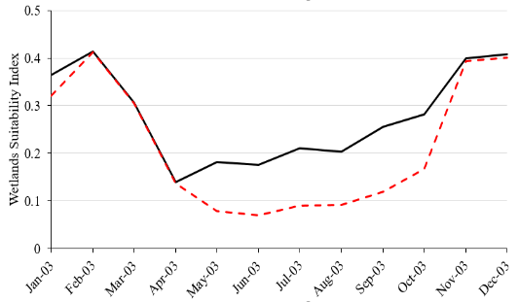
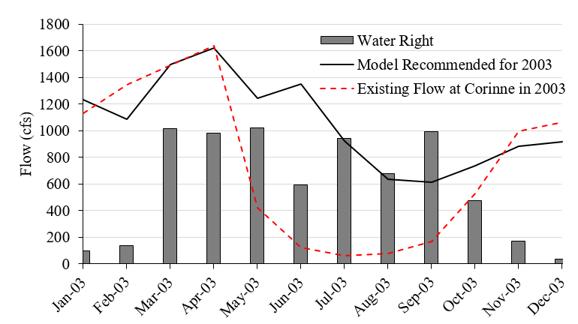
Running the model for 2005 (wet year) increased the suitable habitat area by 18,000acres (Figure 8, red circle), while using 2004 flows (dry year) decreased the suitable habitat area by 15,000 acres (Figure 8, orange triangle). Reducing urban and agricultural demand in 10% increments increased habitat suitability area by approximately 4,000 acres per 10% reduction, with most of the initial increases in habitat area occurring at the Bird Refuge and in aquatic habitat on the Little Bear River. The model becomes infeasible in the 2003 base case scenario when agricultural and urban demands exceed 110% of existing demand.
Figure 7. Model recommended improvements at the Bird Refuge in (A) wetland suitability index and (B) flows
A. Wetland habitat suitability index at the Refuge
B. River flow at the Refuge
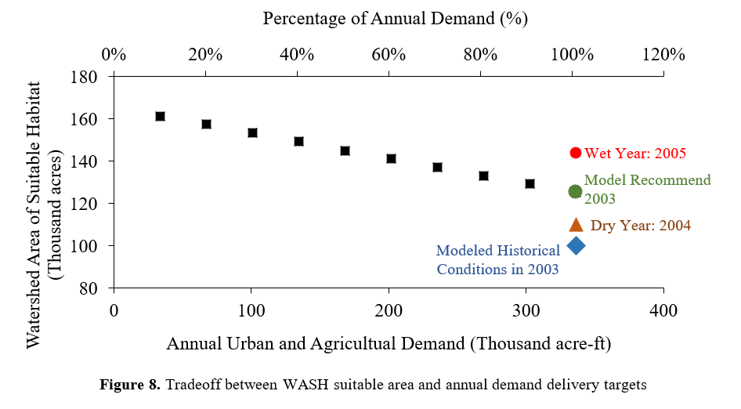
Running the model for 5 years, from January 2003 to September 2007, shows that the model can sustain habitat increases across annual variations in flows. Figure 9 compares the monthly changes in inflow, recommended reservoir operations, and aquatic habitat suitability just downstream of Hyrum and Porcupine reservoirs on the Little Bear River. The figure shows that hydrologic and ecological patterns are very similar and conform to storage and release patterns seen in the single-year run (Figure 5).
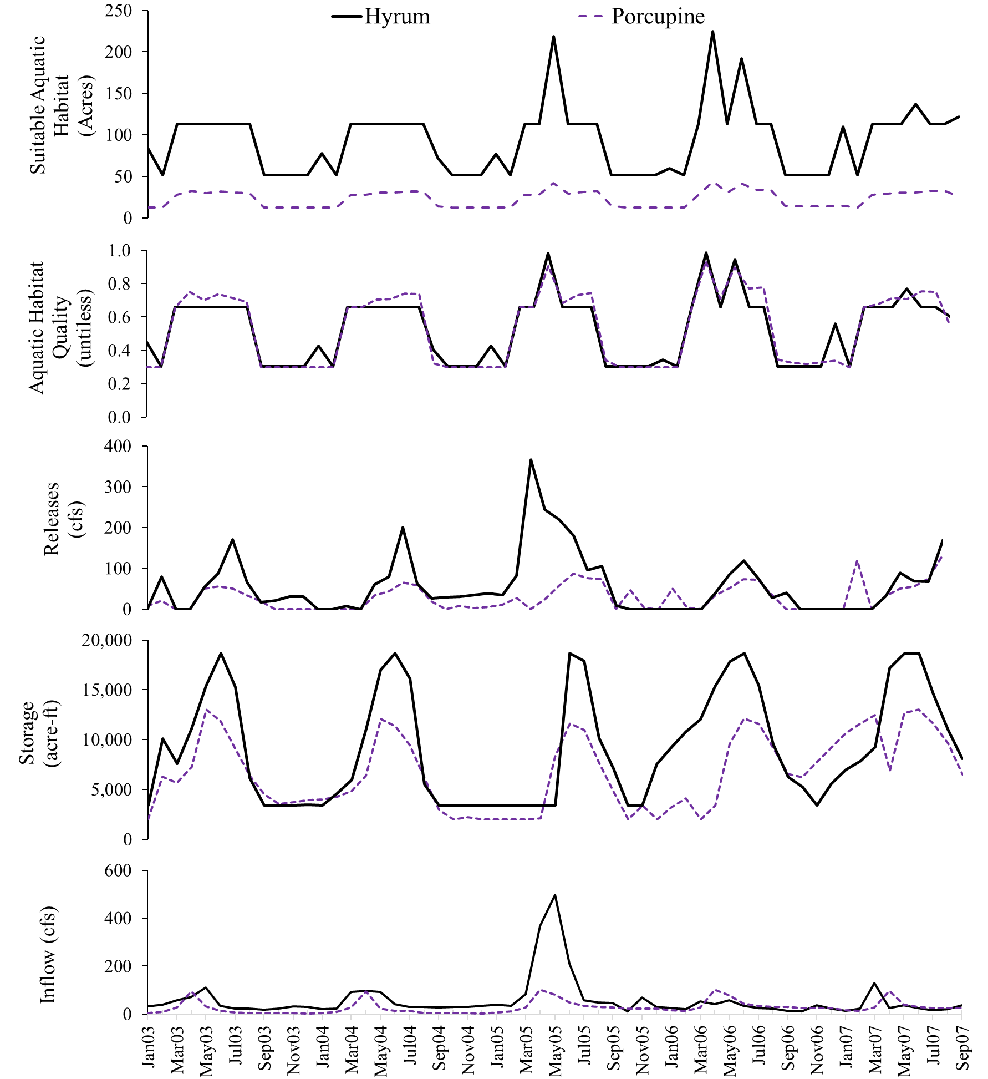
Figure 9. Comparison of 5-year (2003 -2007) model recommended results for Hyrum and Porcupine reservoirs. Suitable aquatic habitat area (acres) and aquatic habitat index (unitless) are the reaches just downstream of the two reservoirs on the Little Bear River, a tributary of the Lower Bear River
Figure 9. Comparison of suitable aquatic habitat area (acres), habitat index (unitless), flow (cfs), and reservoir releases (acre-ft) between model recommendation and modeled historical conditions for 5 years (2003 – 2007) on the Little Bear River downstream of Hyrum Reservoir and just before Cutler dam

To identify when and where additional flow and floodplain vegetation will have the greatest system-wide ecological benefits, we examined the shadow values (Lagrange multipliers) associated with the water mass balance constraints at nodes with headwater flow and vegetation growth constraints along each reach of ecological interest [Appendix B Eqs. 7 and 9]. Shadow values for flow report the increase in the WASH objective function value—habitat area measured in acres—per one additional flow unit (cfs) (Table 2). The largest shadow values occur on the East Fork of the Little Bear River for most months of the year. Shadow values greater than 2.5 acres/cfs are also seen on the Bear River in August, on Blacksmith Fork from April to October, and on the South Fork of the Little Bear in two months. The East and South Forks in addition to Blacksmith Fork had the largest shadow values in the system because both active reservoirs (Hyrum and Porcupine) are located on these reaches, and therefore offer more opportunities to temporally redistribute available water. Shadow values associated with the vegetation growth constraint are largest for all rivers and reaches in winter and spring (Figure 10); reaches on the Malad River and Bear River below Cutler Reservoir will have the largest increase in suitable habitat area per acre of native vegetated area added. We also examined the shadow values for the budget constraint [Appendix B Eq. 18] and found a 30 acre increase in suitable habitat per additional $10,000 available for planting floodplains.

Table 2. Shadow values of additional water by location and month (acres/cfs)
Shadow Values/ Month | Jan | Feb | Mar | Apr | Jun | Jul | Aug | Sep | Oct | Nov | Dec
Bear River | 2.19 | 1.54 | 1.54 | 1.54 | 2.40 | 2.44 | 7.62 | 1.73 | 1.09 | 0.73 | 1.09
Cub River | 1.35 | 0.75 | 0.53 | 2.26 | 0.66 | 2.09 | 0.95 | 0.86 | 1.07 | 0.97 | 0.98
Blacksmith Fork River | 1.80 | 1.20 | 1.10 | 2.87 | 3.29 | 3.25 | 3.32 | 2.43 | 2.50 | 1.41 | 1.42
Little Bear River at East Fork | 4.36 | 3.36 | 4.73 | 2.73 | 3.73 | 4.27 | 7.80 | 12.15 | 3.99 | 3.81 | 3.81
Little Bear River at South Fork | 1.80 | 1.20 | 1.10 | 2.87 | 1.29 | 1.25 | 3.32 | 3.43 | 2.50 | 2.41 | 1.42
Malad River | 0.80 | 0.20 | 0.12 | 0.15 | 0.11 | 0.12 | 0.15 | 0.18 | 0.43 | 0.32 | 0.39

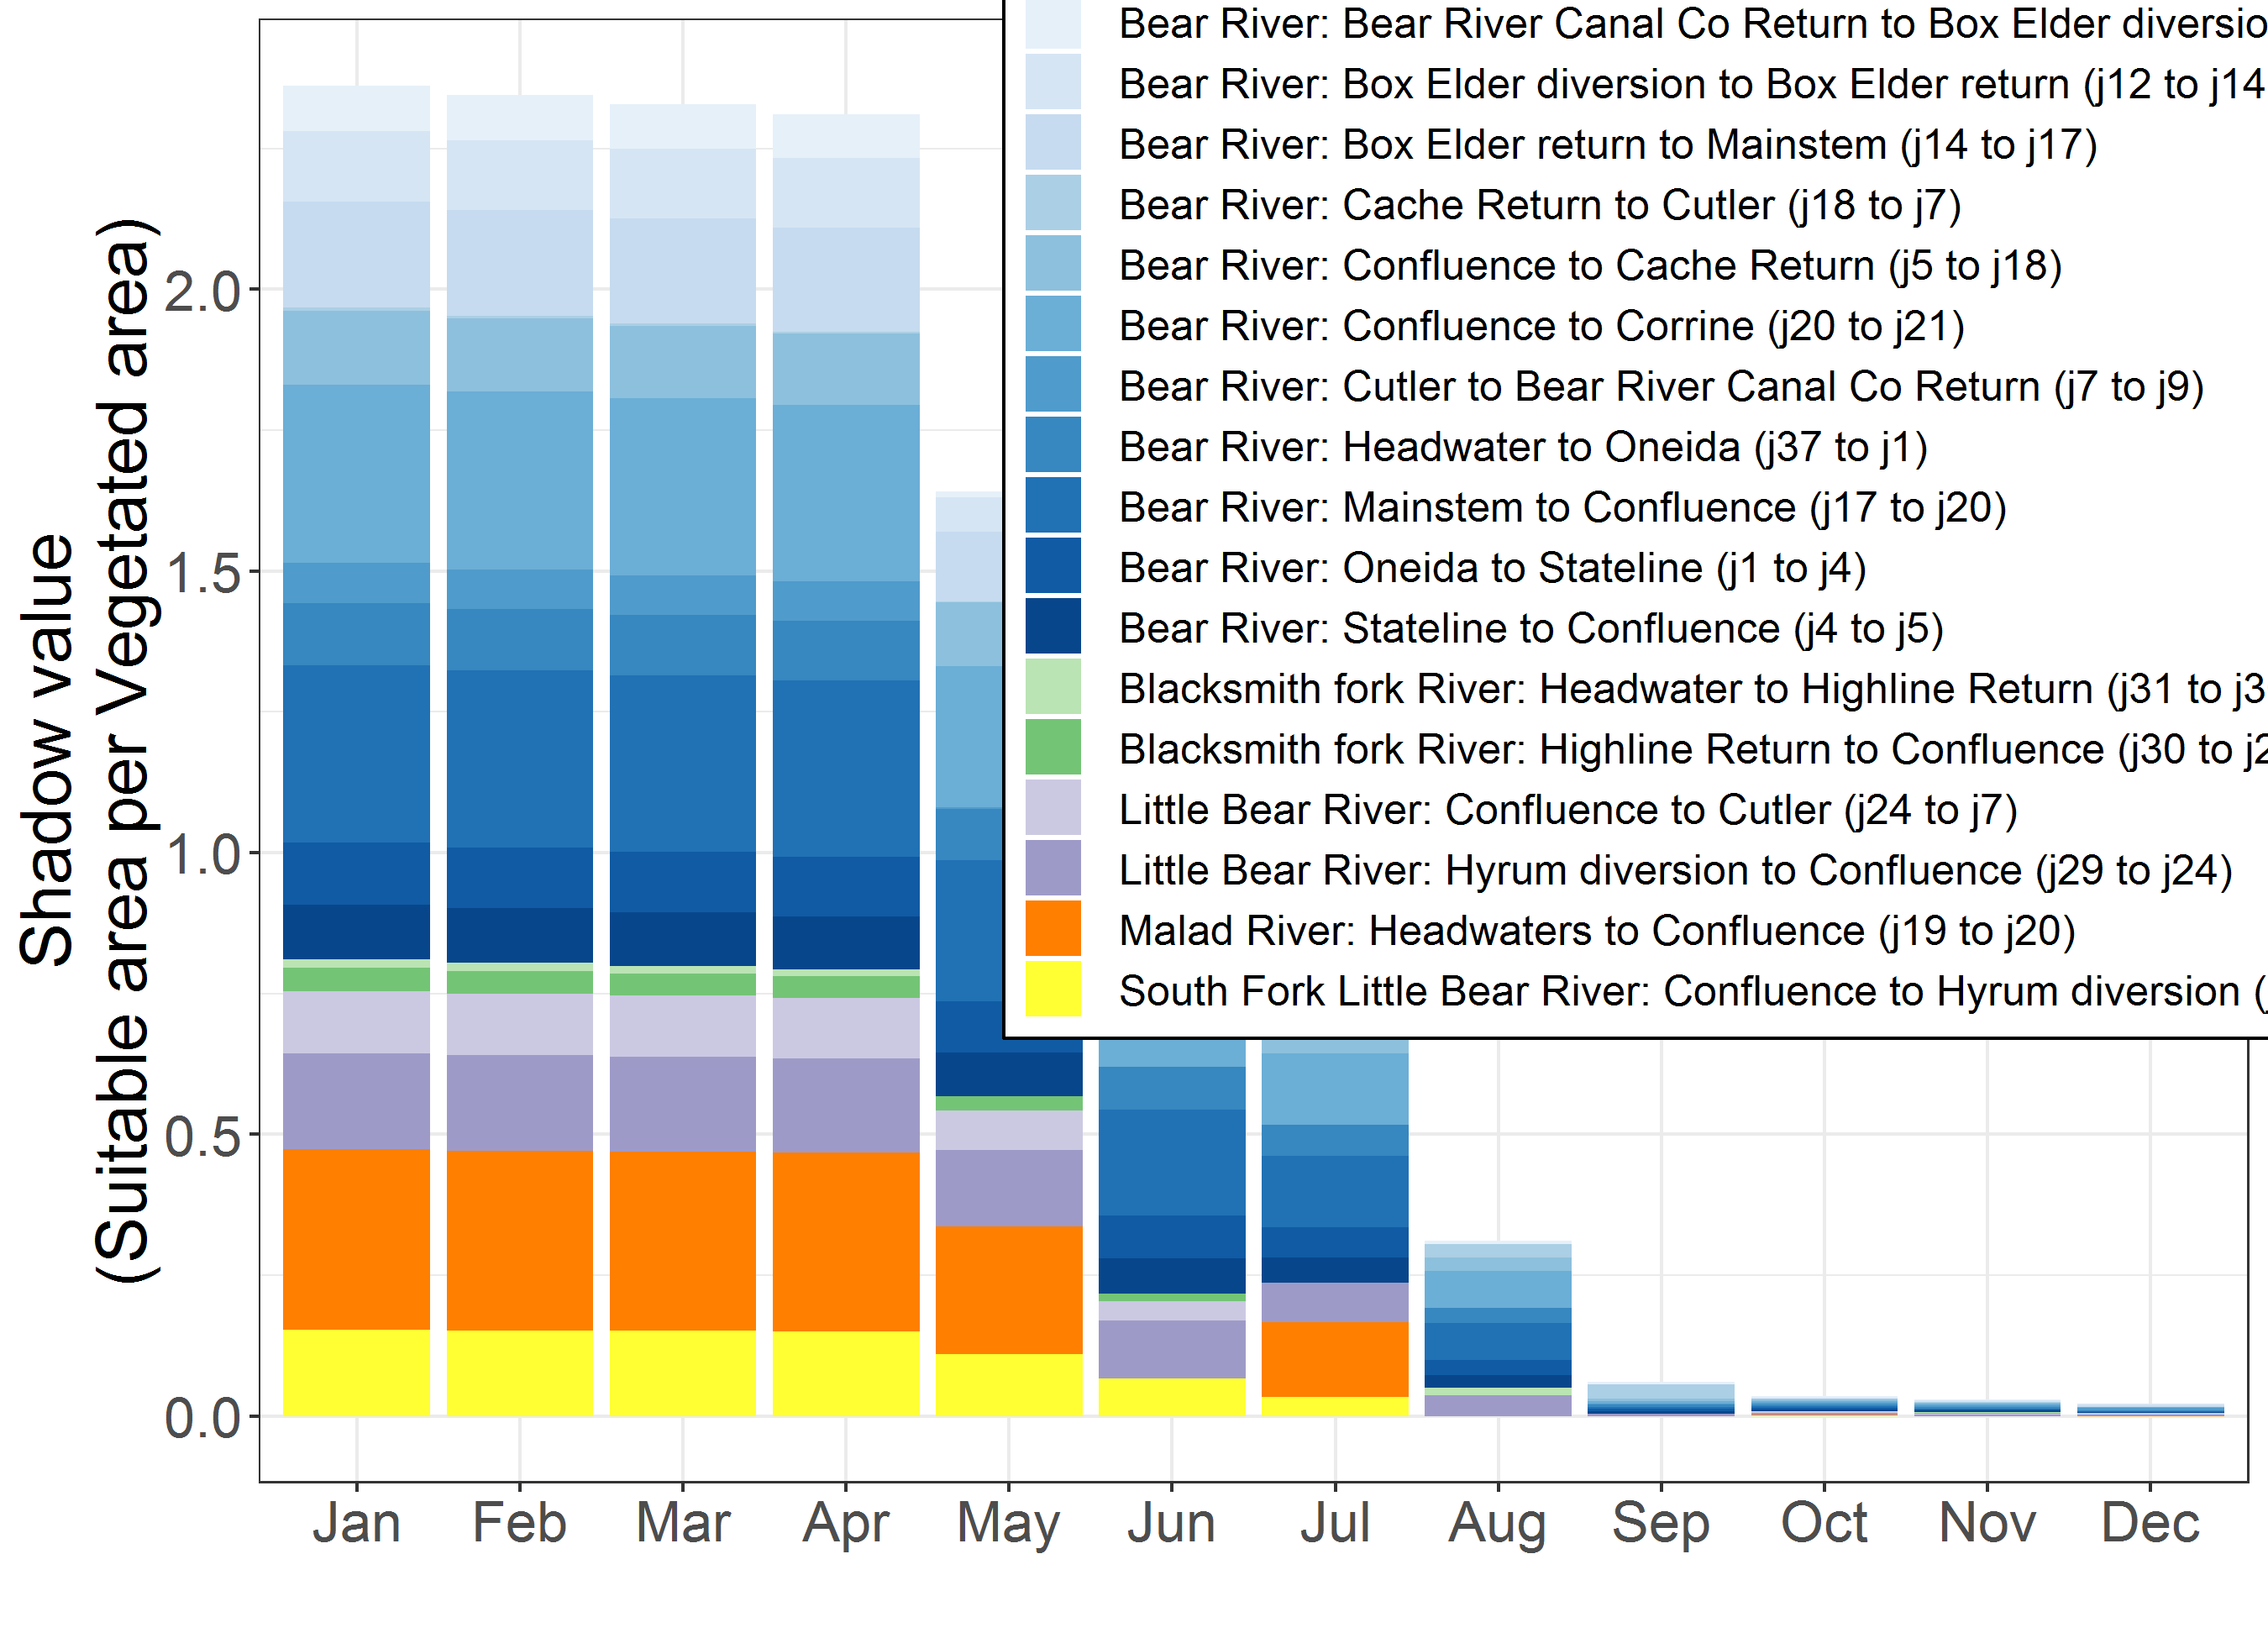
Figure 10. Shadow values of the vegetation growth constraint by river, reach, and month. The shadow value is the suitable habitat area created per vegetated area added.

- Discussion
Formulating the WASH model objective function as a habitat area to maximize allowed us to examine ways to synergistically manage water and plants in the Lower Bear River to increase aquatic, floodplain, and wetland habitat area for priority species while satisfying water demands of existing agricultural and urban users. Additional suitable area can be achieved by: (1) releasing water from reservoirs at times priority species needs water to complete key lifecycle functions, and (2) planting more riparian trees in spring. Spring planting increases vegetation cover and takes advantage of natural vegetation growth over time.
To increase habitat area in the Lower Bear River, the model recommends releasing more water from Porcupine and Hyrum reservoirs in Dec. to Mar. to capture and store April and May spills. This recommended seasonal drawdown supports floodplain connectivity and reduces winter and spring flood events that could scour or kill incubated eggs, newly emerged fry (George et al., 2015), or cottonwood seedlings. Seasonal drawdown could simultaneously help reduce late spring flooding downstream of the reservoirs.
Improvements in floodplain habitat area are small relative to aquatic habitat because several summertime diversions lower instream flows and decrease lateral connectivity to adjacent floodplains. At the same time, many reaches border private agricultural fields and grazing lands and have narrow riparian corridors. Planting native floodplain vegetation according to model recommendations will require managers to set up agreements and easements with riparian landowners. WASH recommended flow regimes will also increase overbank flood recurrence to improve floodplain connectivity. Therefore, managers need to consider flooding effects on neighboring farmers, ranchers, and hunters. Recent conservation easements made by PacifiCorp, which operates many run-of-river hydropower facilities and owns large floodplain areas, illustrate one way to co-manage for multiple objectives. These easements have allowed riparian plant restoration projects to also serve as flood buffer zones. WASH results can help identify promising locations to site additional conservation easements to improve habitat quality for multiple aquatic and floodplain priority species.
Changing reservoir operations, diversions, and other management actions higher up in the basin can also increase impounded wetland habitat during summer months. These results support Bird Refuge managers’ recent efforts to establish conservation easements with upstream landowners. Acquiring upstream storage rights would allow Refuge managers to store winter flows and release in summer to beneficially improve habitat for Avocets and Stilts. Storage rights could also help managers plan for droughts.
Formulating the WASH objective function as a habitat area to maximize also shows where and when to direct scarce water, money, and planting efforts to most improve habitat. Water is scarce during summer months, but WASH results suggest managers can create 2.5 to 12 acres of additional suitable habitat per additional cfs of flow acquired during summer, fall, or winter on the East Fork of the Little Bear River or during late summer and fall months on the Blacksmith Fork or South Fork of the Little Bear River. The Little Bear had the greatest return per additional cfs because it has aquatic and floodplain habitat that need just a little more water to improve to good habitat condition. These flows will also benefit downstream reaches. Similarly, WASH model recommendations to plant native floodplain vegetation in spring replicate findings by Alminagorta et al (2016) to remove invasive wetland vegetation at the beginning of the growing season to see the largest increases in suitable wetland habitat area.
WASH results were corroborated using a participatory modeling approach (Bockstaller and Girardin, 2003). Stakeholders initially helped to define the aquatic, floodplain, and wetland metrics. Later, we presented results to project stakeholders using WASH interactive web map (http://washmap.usu.edu). For example, during an August 2016 model workshop, we presented key reservoir release and habitat area results (earlier versions of Figures 4-5 and 7-9) while stakeholders simultaneously explored results in real time on their phones, tablets, and laptops. Their explorations identified a problematic aspect of reservoir releases for BCT and motivated us to update aquatic suitability indices to reflect temperature-water depth relationships, base water depth ranges on recent fish ecology studies, and differentiate BCT and brown trout distributions.
Because WASH multiplies habitat suitability indices by affected areas, the model structure is flexible and can be extended to explicitly include additional water quality parameters such as dissolved oxygen or turbidity. Similarly, modelers can add other species, habitat attributes, or habitat types such as natural, oxbow, seasonal, or other wetlands in the watershed that were not included in the Lower Bear River study.
The WASH model quantifies some habitat quality conditions that are necessary for the survival and productivity of priority species. However, it does not predict or model species distribution across the watershed. While we have validated habitat quality conditions with available and collected cutthroat trout and cottonwood tree sightings, we see further value to collect additional field data that describe fish growth, in-migration, out-migration, predators, natural die off, and other factors, and couple models of these species distribution processes to the WASH model.
The WASH model assumes that measured and modeled water depths and channel widths are uniform along reaches that are a few miles long. Also, that suitable area varies in time and is separable by habitat type, species, species life stage, and location. These assumptions were made using the best available, measured data and do not capture species resilience to or recovery from very poor conditions. A finer spatial resolution or coupling our model with a hydrologic model could improve our findings. At the same time, the model results increase or sustain suitable habitat areas for each habitat type, species, and species life stage compared to modeled historical conditions.
We also assume that inundating the floodplains during seed germination and dispersal will help riparian plants to reestablish. This assumption neglects seedling survival, which requires other biotic and abiotic conditions such as groundwater level, soil salinity, and plant competition for water (Bhattacharjee et al., 2008). We recognize that each of the aquatic, floodplain, and impounded wetland suitability indices (SI) carry along statistical errors that result from measurement error, spatial and temporal variability, and function form (Van der Lee et al., 2006). More spatially resolved ecological data can help determine where finer and coarser data is appropriate for modeling. In ongoing research, we are evaluating and quantifying uncertainties in SI curves and other model parameters and their implications for water management (Alafifi, 2018).
The WASH model also allocates water and vegetation using perfect foresight of future water flows and vegetation growth rates. Managers never have perfect information about these factors. However, Bear River flows are snowmelt driven, and managers use snowpack measurements throughout the winter and spring to forecast spring, summer, and fall river flows. Forecast reliability decreases in successive years; thus multi-year scenario results are more appropriately interpreted as the upper bound on potential habitat gains (when future flows are known perfectly).
Implementing WASH recommendations to improve habitat will also require recognizing and protecting environmental flows in the water permitting process. Utah water law has limited methods to appropriate water for instream flow, (Szeptycki et al., 2015) and must allow more entities to donate, lease, or purchase existing water rights (Lane and Rosenberg, 2018; Szeptycki et al., 2015). Expanding the allowed entities will reduce risks that a downstream water right holder will appropriate an instream flow for their beneficial use. Currently, managers in the basin such as the Cache Water District are investigating ways they and others can hold instream flow rights.

- Conclusions
Improving habitat in a watershed requires determining when, where, and how to allocate water and vegetation planting efforts within a basin. Prior systems models to improve habitat have principally focused on the water allocation component. These models either maximized human benefits of water or included habitat quality as a flow constraint. Other models minimized deviations from natural or species-required flow regimes. Here, we developed a suitable habitat area metric measured in acres that is tied to flow and native vegetation conditions in the watershed. We embedded the metric in a systems optimization model named WASH that identified the timing and location of reservoir releases, river flows, and planting efforts to maximize habitat area subject to physical, infrastructure, and management constraints.
We applied WASH to the Lower Bear River, UT using stakeholder-verified species- and site-specific habitat suitability curves for cutthroat trout, brown trout, cottonwood, black-necked stilt, American avocet, and tundra swan. WASH identified opportunities to increase aquatic, floodplain, and impounded wetland habitat area by 25,000 acres over existing conditions. This increase can be realized by releasing more water from Porcupine and Hyrum reservoirs in winter months, using vacated storage to capture spring runoff, and reducing late spring spills. Also, by planting native floodplain vegetation in spring months in reaches with low vegetation cover. Further, procuring additional flow in the East Fork of the Little Bear River during summer, fall, and winter months would most increase habitat area per cfs of new flow. The WASH web map application provided managers with direct access to model results, helped us validate results, and motivated further model development to make scenarios and results more relevant to managers. Overall, developing and embedding a habitat area metric in a systems model as an ecological objective to maximize has allowed us to compare habitats across watershed sites and identify sites and times where managers can apply scarce water, money, and planting efforts to most improve habitat quality and area.

Acknowledgements
This research was supported by National Science Foundation (NSF) grant #1149297. Joan Degiorgio, Bryan Dixon, Bob Fotheringham, James DeRito, Paul Thompson, Sarah Null, and Karin Kettenring contributed to the model development and provided feedback on results. 16 undergraduate Bear River fellows helped collect, synthesize, and analyze flow, stage, and cross sectional data plus tested model scenarios.

References
Adams, T.D., Cole, D.B., Miller, C.W., Stauffer, N.E., 1992. GENRES A Computer Program System for Reservoir Operation with Hydropower, In: Resources, U.D.o.W. (Ed.).
Ahmadi-Nedushan, B., St-Hilaire, A., Berube, M., Robichaud, E., Thiemonge, N., Bobee, B., 2006. A review of statistical methods for the evaluation of aquatic habitat suitability for instream flow assessment. River Research and Applications 22(5) 503-523.
Alafifi, A., 2017. ayman510/WASH: First release of WASH code. doi:10.5281/zenodo.801509. URL: https://github.com/ayman510/WASH
Alafifi, A., 2018. Integrated Systems Modeling to Improve Watershed Habitat Management and Decision Making, Civil and Environmental Engineering. Utah State University: Logan, UT, USA.
Alminagorta, O., Rosenberg, D.E., Kettenring, K.M., 2016. Systems modeling to improve the hydro-ecological performance of diked wetlands. Water Resources Research 52(9) 7070-7085.
Anderson, R., Stewart, G., 2003. Riverine Fish Flow Investigations, In: F-289-R6, F.A.P. (Ed.), Federal Aid in Fish and Wildlife Restoration - Job Progress Report Colorado Division of Wildlife Fort Collins, Colorado.
Barbour, E.J., Holz, L., Kuczera, G., Pollino, C.A., Jakeman, A.J., Loucks, D.P., 2016. Optimisation as a process for understanding and managing river ecosystems. Environmental Modelling & Software 83 167-178.
Baron, J.S., Poff, N.L., Angermeier, P.L., Dahm, C.N., Gleick, P.H., Hairston, N.G., Jackson, R.B., Johnston, C.A., Richter, B.D., Steinman, A.D., 2002. Meeting Ecological and Societal Needs for Freshwater. Ecological Applications 12(5) 1247-1260.
Bear River CAP, 2008. The Bear River, A conservation priority. The Nature Conservnacy: Utah.
Bernhardt, E.S., Palmer, M.A., Allan, J.D., Alexander, G., Barnas, K., Brooks, S., Carr, J., Clayton, S., Dahm, C., Follstad-Shah, J., Galat, D., Gloss, S., Goodwin, P., Hart, D., Hassett, B., Jenkinson, R., Katz, S., Kondolf, G.M., Lake, P.S., Lave, R., Meyer, J.L., O'Donnell, T.K., Pagano, L., Powell, B., Sudduth, E., 2005. Ecology - Synthesizing US river restoration efforts. Science 308(5722) 636-637.
Bhattacharjee, J., Taylor, J., Smith, L., 2006. Controlled flooding and staged drawdown for restoration of native cottonwoods in the Middle Rio Grande Valley, New Mexico, USA. Wetlands 26(3) 691-702.
Bhattacharjee, J., Taylor, J.P., Smith, L.M., Spence, L.E., 2008. The Importance of Soil Characteristics in Determining Survival of First-Year Cottonwood Seedlings in Altered Riparian Habitats. Restoration Ecology 16(4) 563-571.
Bio-West, 2015. Little Bear and Blacksmith Fork Rivers Environmental Flows: Background Report. Bio-West Inc.: Logan, UT.
Bockstaller, C., Girardin, P., 2003. How to validate environmental indicators. Agricultural Systems 76(2) 639-653.
Braithwaite, N.R., 2011. The Effect of Stream Restoration on Preferred Cutthroat Trout Habitat in the Strawberry River, Utah, Watershed Sciences. Utah State Univeristy: Logan, UT, p. 950.
Bunn, S.E., Arthington, A.H., 2002. Basic Principles and Ecological Consequences of Altered Flow Regimes for Aquatic Biodiversity. Environmental Management 30(4) 492-507.
Carignan, V., Villard, M.-A., 2002. Selecting Indicator Species to Monitor Ecological Integrity: A Review. Environmental Monitoring and Assessment 78(1) 45-61.
Cioffi, F., Gallerano, F., 2012. Multi-objective analysis of dam release flows in rivers downstream from hydropower reservoirs. Applied Mathematical Modelling 36(7) 2868-2889.
Dettenmaier, M., Howe, F.P., 2015. Taking Care of Streams and Rivers in Cache Valley, USU Extension. Utah State University: Logan, Utah.
Downard, R., Endter-Wada, J., 2013. Keeping wetlands wet in the western United States: Adaptations to drought in agriculture-dominated human-natural systems. Journal of Environmental Management 131 394-406.
Downard, R., Endter-Wada, J., Kettenring, K.M., 2014. Adaptive wetland management in an uncertain and changing arid environment. Ecology and Society 19(2).
Faulkner, S., Barrow, W., Keeland, B., Walls, S., Telesco, D., 2010. Effects of conservation practices on wetland ecosystem services in the Mississippi Alluvial Valley. Ecological Applications 21(sp1) S31-S48.
Garcia-Rodriguez, E., Martinez-Austria, P.F., de Jalon-Lastra, D.M.G., Martinez-Capel, F., 2008. Physical habitat simulation in a stretch of the Lozoya River using the PHABSIM system. Ingenieria Hidraulica En Mexico 23(4) 41-52.
George, S.D., Baldigo, B.P., Smith, A.J., Robinson, G.R., 2015. Effects of extreme floods on trout populations and fish communities in a Catskill Mountain river. Freshwater Biology 60(12) 2511-2522.
Gosse, R. S. Wydoski, Helm, W.T., 1977. Microhabitat of fish in intermountain rivers. Utah State University, Logan, UT: Utah Coop. Fish. Res. Unit.
Gosse, J.C., 1981. Brown trout (Salmo trutta) responses to stream channel alterations, their microhabitat requirements, and a method for determining microhabitat in lotic systems. Utah State University: Logan, UT, p. 138 pp.
Harman, C., Stewardson, M., 2005. Optimizing dam release rules to meet environmental flow targets. River Research and Applications 21(2-3) 113-129.
Hemker, T., Fowler, K.R., Farthing, M.W., von Stryk, O., 2008. A mixed-integer simulation-based optimization approach with surrogate functions in water resources management. Optimization and Engineering 9(4) 341-360.
Hickey, J., Fields, W., 2013. HEC-EFM Ecosystem Functions Model. US Army Corps of Engineers - Hydrologic Engineering Center.
Hickman, T., Raleigh, R., 1982. Habitat Suitability Index Models: Cutthroat Trout, Biological Services Program. Fish and Wildlife Service.
Higgins, A.J., Bryan, B.A., Overton, I.C., Holland, K., Lester, R.E., King, D., Nolan, M., Connor, J.D., 2011. Integrated modelling of cost-effective siting and operation of flow-control infrastructure for river ecosystem conservation. Water Resources Research 47(5) W05519.
Hooper, B., 2010. River basin organization performance indicators: application to the Delaware River basin commission. Water Policy 12(4) 461-478.
Hozlar, E., 1990. Gams - General Algebraic Modeling System for Mathematical-Modeling. Ekonomicko-Matematicky Obzor 26(1) 96-99.
Jackson, D.A., Peres-Neto, P.R., Olden, J.D., 2001. What controls who is where in freshwater fish communities - the roles of biotic, abiotic, and spatial factors. Canadian Journal of Fisheries and Aquatic Sciences 58(1) 157-170.
Jager, H.I., Smith, B.T., 2008. Sustainable reservoir operation: can we generate hydropower and preserve ecosystem values? River Research and Applications 24(3) 340-352.
Johnstone, H.C., Rahel, F.J., 2003. Assessing Temperature Tolerance of Bonneville Cutthroat Trout Based on Constant and Cycling Thermal Regimes. Transactions of the American Fisheries Society 132(1) 92-99.
JUB Engineers, 2013. Cache County Water Master Plan. Cache County: Logan, Utah, p. 375.
Kilpatrick, F.A., Barnes, H.H., 1964. Channel Geometry of Piedmont Streams as Related to Frequency of Floods, In: Interior, U.S.D.o.t. (Ed.), Physiographic and Hydraulic Studies of Rivers: Washington D.C.
Lane, B.A., Rosenberg, D.E., 2018. Expanding Instream Flows to Protect Ecosystems in Overallocated River Basins, Reports. Utah State University: Logan.
Leopold, L.B., Maddock, T., 1953. The hydraulic geometry of stream channels and some physiographic implications, In: Paper, G.S.P. (Ed.). US Government Printing Office: Washington.
Li, C., Czapiga, M.J., Eke, E.C., Viparelli, E., Parker, G., 2015. Variable Shields number model for river bankfull geometry: bankfull shear velocity is viscosity-dependent but grain size-independent. Journal of Hydraulic Research 53(1) 36-48.
Mahoney, J., Rood, S., 1998. Streamflow requirements for cottonwood seedling recruitment—An integrative model. Wetlands 18(4) 634-645.
Meier, C.I., Hauer, F.R., 2010. Strong effect of coarse surface layer on moisture within gravel bars: Results from an outdoor experiment. Water Resources Research 46.
Merritt, D.M., Scott, M.L., Poff, N.L., Auble, G.T., Lytle, D.A., 2010. Theory, methods and tools for determining environmental flows for riparian vegetation: riparian vegetation-flow response guilds. Freshwater Biology 55(1) 206-225.
Moir, H.J., Gibbins, C.N., Soulsby, C., Youngson, A.F., 2005. PHABSIM modelling of Atlantic salmon spawning habitat in an upland stream: testing the influence of habitat suitability indices on model output. River Research and Applications 21(9) 1021-1034.
NHDPlus V2, 2016. NHD Plus V2 Attribute Extensions, In: Systems, H. (Ed.), Great Basin (Vector Processing Unit 16). Esri.
Nikouei, A., Zibaei, M., Ward, F.A., 2012. Incentives to adopt irrigation water saving measures for wetlands preservation: An integrated basin scale analysis. Journal of Hydrology 464–465(0) 216-232.
NOAA, 2015. High Water Level Terminology: Alaska - pacific River Forecast Center.
Null, S.E., Medellín-Azuara, J., Escriva-Bou, A., Lent, M., Lund, J.R., 2014. Optimizing the dammed: Water supply losses and fish habitat gains from dam removal in California. Journal of Environmental Management 136(0) 121-131.
Parker, G., Wilcock, P.R., Paola, C., Dietrich, W.E., Pitlick, J., 2007. Physical basis for quasi-universal relations describing bankfull hydraulic geometry of single-thread gravel bed rivers. Journal of Geophysical Research-Earth Surface 112(F4).
Pinto, R., Patricio, J., Baeta, A., Fath, B.D., Neto, J.M., Marques, J.C., 2009. Review and evaluation of estuarine biotic indices to assess benthic condition. Ecological Indicators 9(1) 1-25.
Poff, N.L., Allan, J.D., Bain, M.B., Karr, J.R., Prestegaard, K.L., Richter, B.D., Sparks, R.E., Stromberg, J.C., 1997. The natural flow regime. Bioscience 47(11) 769-784.
Porse, E.C., Sandoval-Solis, S., Lane, B.A., 2015. Integrating Environmental Flows into Multi-Objective Reservoir Management for a Transboundary, Water-Scarce River Basin: Rio Grande/Bravo. Water Resources Management 29(8) 2471-2484.
Raleigh, R.F., Zuckerman, L.D., Nelson, P.C., 1984. Habitat suitability index models and instream flow suitability curves: Brown trout, Biological Report, 10.24 ed. U.S. Fish and Wildlife Service, p. 65.
Richter, B.D., Richter, H.E., 2000. Prescribing Flood Regimes to Sustain Riparian Ecosystems along Meandering Rivers
Prescripción de Regímenes de Inundación para Mantener Ecosistemas Riparios a lo Largo de Ríos Sinuosos. Conservation Biology 14(5) 1467-1478.
Rivaes, R., Rodríguez-González, P.M., Albuquerque, A., Pinheiro, A.N., Egger, G., Ferreira, M.T., 2013. Riparian vegetation responses to altered flow regimes driven by climate change in Mediterranean rivers. Ecohydrology 6(3) 413-424.
Rogers, K., Ralph, T.J., 2011. Floodplain Wetland Biota in the Murray-Darling Basin: Water and Habitat Requirements. CSIRO Publishing.
Roloff, G.J., Kernohan, B.J., 1999. Evaluating Reliability of Habitat Suitability Index Models. Wildlife Society Bulletin (1973-2006) 27(4) 973-985.
Rood, S.B., Braatne, J.H., Hughes, F.M.R., 2003. Ecophysiology of riparian cottonwoods: stream flow dependency, water relations and restoration†. Tree Physiology 23(16) 1113-1124.
Rood, S.B., Samuelson, G.M., Braatne, J.H., Gourley, C.R., Hughes, F.M.R., Mahoney, J.M., 2005. Managing river flows to restore floodplain forests. Frontiers in Ecology and the Environment 3(4) 193-201.
Rosgen, D.L., 1994. A classification of natural rivers, In: Catena (Ed.), pp. 169-199.
Ryu, J., Palmer, R., Jeong, S., Lee, J., 2003. An Optimization Model to Mitigate Conflicts in the Geum River Basin, Korea, World Water & Environmental Resources Congress 2003. American Society of Civil Engineers, pp. 1-10.
Sahinidis, N.V., 1996. BARON: A general purpose global optimization software package. Journal of Global Optimization 8 201-205.
Simonović, S.P., Nirupama, 2005. A spatial multi-objective decision-making under uncertainty for water resources management. Journal of Hydroinformatics 7(2) 117-133.
Souchon, Y., Capra, H., 2004. Aquatic habitat modelling: biological validations of IFIM/Phabsim methodology and new perspectives. Hydroécol. Appl. 14 9-25.
Stalnaker, C.B., B.L. Lamb, J. Henriksen, K. Bovee, and J. Bartholow, 1995. The Instream Flow Incremental Methodology: A Primer for IFIM. . Washington, DC: US Geological Survey Biological Report 29 45.
Steinschneider, S., Bernstein, A., Palmer, R., Polebitski, A., 2014. Reservoir Management Optimization for Basin-Wide Ecological Restoration in the Connecticut River. Journal of Water Resources Planning and Management 140(9) 04014023.
Szemis, J.M., Maier, H.R., Dandy, G.C., 2012. A framework for using ant colony optimization to schedule environmental flow management alternatives for rivers, wetlands, and floodplains. Water Resources Research 48.
Szemis, J.M., Maier, H.R., Dandy, G.C., 2014. An adaptive ant colony optimization framework for scheduling environmental flow management alternatives under varied environmental water availability conditions. Water Resources Research 50(10) 7606-7625.
Szeptycki, L.F., Forgie, J., Hook, E., Lorick, K., Womble, P., 2015. Environmental Water Rights Transfers: A Review of State Laws. Water in the West for The National Fish and Wildlife Foundation: Stanford, CA.
Tharme, R.E., 2003. A global perspective on environmental flow assessment: emerging trends in the development and application of environmental flow methodologies for rivers. River Research and Applications 19(5-6) 397-441.
UDWR, 2004. Utah Division of Water Resources, Bear River Basin, Planning for the Future: Utah.
UDWRe, 2000. Bear River Development, Utah Divion of Water Resources: Salt Lake City, UT.
USDA, 2014. USA NAIP Imagery: NDVI, Esri Living Atlas of the World.
USGS, 2012. USA NHDPlusV2, Esri Living Atlas of the World.
UtahFishingInfo Website, 2016. Brown Trout.
UWRL, 2009. Little Bear River WATERS Test Bed. Utah Water Research Laboratory, Utah State University: Logan, UT.
Van der Lee, G.E.M., Van der Molen, D.T., Van den Boogaard, H.F.P., Van der Klis, H., 2006. Uncertainty analysis of a spatial habitat suitability model and implications for ecological management of water bodies. Landscape Ecology 21(7) 1019-1032.
Watershed Sciences, 2007. Airborne Thermal Infrared Remote Sensing Bear River Basin, ID/WY/UT Pacificorp and Trout Unlimited: Corvallis, OR.
Yang, W., 2011. A multi-objective optimization approach to allocate environmental flows to the artificially restored wetlands of China's Yellow River Delta. Ecological Modelling 222(2) 261-267.
Yarnell, S.M., Viers, J.H., Mount, J.F., 2010. Ecology and Management of the Spring Snowmelt Recession. Bioscience 60(2) 114-127.

Appendix A: Additional Figures and Tables
Figure A1. Example WASH wetland suitability index for February

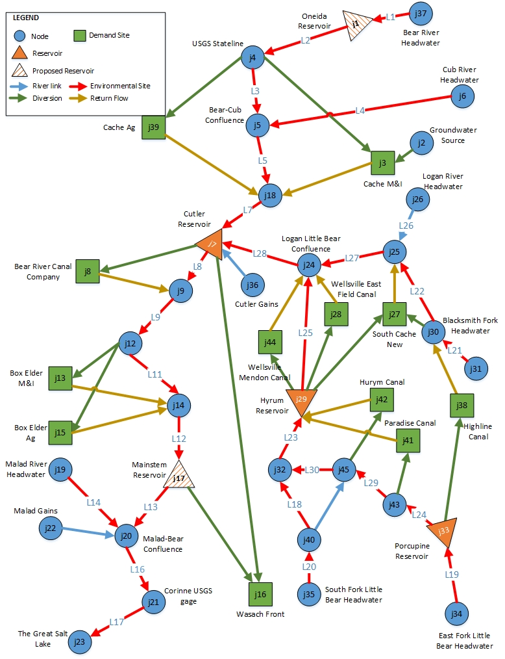
Figure A2. WASH model schematic for the Lower Bear River, Utah basin.
Table A1. Data required for WASH model components
Figure A1. Lower Bear River network represented as a group of nodes and links
Model Component | Data Item | Source(s) | Component Type
Aquatic Habitat | Reach lengths | NHDPlus V2 (2016), USGS (2012), field measurements | Link
Aquatic Habitat | Water depth-ecological suitability curves | FWS, stakeholders, and literature | Link
Floodplain Habitat | Plant cover and distance from banks | USDA (2014) NAIP Imagery, field measurements | Link
Floodplain Habitat | Floodplain area | NAIP Imagery, field measurements | Link
Floodplain Habitat | Flow-ecological suitability curves | FWS, stakeholders, and literature | Link
Wetland Habitat | Wetland unit water level-storage curves | LiDAR, field measurements | Link
Wetland Habitat | Invasive plan cover | Landsat satellite imagery | Link
Wetland Habitat | Evaporation rates | Western Regional Climate Center | Link
Wetland Habitat | Flow-ecological suitability curves | FWS, stakeholders, and literature | Link
Physical Constraints | Reservoirs storage-elevation-area, evaporation, and capacity | Adams et al. (1992), U.S. BoR | Node
Physical Constraints | Diversions capacity | Adams et al. (1992) | Link
Natural Constraints | Headwater and local inflows | USGS, NHDPlus V2, UWRL (2009) | Node
Natural Constraints | Water level and channel cross section | Field measurements | Link
Natural Constraints | Evaporative losses on reaches | NHDPlus V2 | Link
Natural Constraints | Natural growth of riparian plants | Stakeholders | Link
Management Constraints | Urban and agricultural demand | GenRes | Node
Management Constraints | Consumptive use of flow | GenRes | Node
Management Constraints | Instream flow requirements | Stakeholders | Link
Management Constraints | Budget and unit costs | Stakeholders | Link
Model Formulation | Weights | Stakeholders | Link

Appendix B: WASH model constraints

This appendix describes the physical [eqs. 5-14], infrastructure [eq. 15], and management [eq. 16-18] constraints that limit reservoir release, diversion, planting, and other decisions in the WASH model.
  - Reservoir storage balance. A low-order, finite-difference mass balance requires that reservoir storage for each reservoir v at the beginning of each time step t+1 equal storage at the beginning of the prior time step t plus net flows of links leading to the reservoir minus reservoir releases and minus evaporation losses [eq. 5]. Reservoir releases are flows along all links that leave reservoir v in month t [eq. 6]. Evaporation losses are estimated by multiplying a monthly evaporative rate ${evap}_{v,t}$ [m/month] by the reservoir surface area. ${RA}_{v,t} is$a function of reservoir storage. The term ${lss}_{j,v,t}$ [%] is the net loss rate on links connecting to reservoir v and is expressed as a fraction of link flow.
${STOR}_{v,t+1}={STOR}_{v,t}+\sum_{j}{\left[Q_{j,v,t}∙(1-{lss}_{j,v,t})\right]}-{RR}_{v,t}- \left[{evap}_{v,t}∙{RA}_{v,t}\left({STOR}_{v,t}\right)\right] ∀v,t$ [5]
$RR_{v,t}$ = $\sum_{j}{ Q_{v,j,t}}$ $∀v,t$ [6]
  - Mass balance at junctions. Flows entering each non-reservoir node j must equal or exceed evaporative losses plus flows leaving the node [eq. 7]. localInflow_{j,t} [Mm³/month] are reach gains, groundwater inflows, or other flows that accumulate at node j in time t. At the most upstream nodes in a network, localInflow is the head flow and represents the boundary condition and cumulative contribution of climate, runoff, and other hydrologic processes. linkEvap [m/month] describes the evaporative loss rate on links; link evaporation [m³/month] is the product of the evaporative loss rate and channel surface area.
${localInflow}_{j,t}+ \sum_{k}{Q_{k,j,t}∙\left(1-{lss}_{k,j,t}\right)- \sum_{k}{A_{k,j,t}∙{linkEvap}_{k,j,t} ≥ }}\sum_{k}{\left[Q_{j,k,t}\right] ∀j,t}$ [7]
  - Mass balance at each demand site. Total flow to each demand site dem in time t must equal or exceed the return flow back to the river [eq. 8]. Total flow is reduced by the depleted flow amounts that include diversion losses ${lss}_{k,dem,t}$ and urban or agricultural consumptive use fraction ${Cons}_{k,dem,t}$ [both % of inflow received].
$\sum_{k}{Q_{k,dem,t}∙\left(1-{lss}_{k,dem,t}\right)∙{Cons}_{dem,t}≥} \sum_{k}{Q_{dem,k,t}} ∀dem,t$ [8]
  - Plant cover. Plant cover $C_{j,k,t,n}$[Mm²] for each species n in each link j to k at time step t equals cover at prior time step t-1 plus planted areas ${RV}_{j,k,n}$ [Mm²] and natural growth or death $g_{j,k,n}$ [Mm²; eq. 9]. $g_{j,k,n}$ describes the natural increase or decrease in riparian plant cover without any interference from managers. Both plant cover $C_{j,k,t,n}$ and planting area cannot exceed the total floodplain area adjacent to each reach ${cmax}_{j,k}$ [eqs. 10 and 11]. Additionally, planting ${RV}_{j,k,n}$ can only occur during the growing season [eq. 11]
$C_{j,k,t,n}=C_{j,k,t-1,n}+ {RV}_{j,k,t,n}+g_{j,k,n}$ $∀ j,k,t,n$ [9]
$\sum_{n}{C_{j,k,t,n}}≤ {cmax}_{j,k}$ $∀ j,k,t$ [10]
$\sum_{n}{{RV}_{j,k,t,n}}≤\left\{\begin{aligned}{cmax}_{j,k}, & t ∈growing season \\ 0, &otherwise\end{aligned}\right.$ $∀ j,k,t$ [11]
  - Channel topology relationships. River flow, channel stage$,$width, and surface area are related on each link j to k in each time step t [eqs. 12-14]. These relationships are established based on measured data. We use Leopold and Maddock (1953) linear relationships for stage-flow ($sf)$and width-flow ($wf)$ relationships. ${lng}_{j,k}$ is the length of each river segment [m].
Stage-flow relationships: $D_{j,k,t}={sf}_{1j,k}{∙Q}_{j,k,t}+ {sf}_{2j,k}$ $∀ j,k,t$ [12]
Width-flow relationships: ${WD}_{j,k,t}={wf}_{1j,k}{∙Q}_{j,k,t}+ {wf}_{2j,k}$ $∀ j,k,t$ [13]
Channel surface area: $A_{j,k,t}= {WD}_{j,k}∙{lng}_{j,k } ∀ j,k,t$ [14]
  - Reservoir storage limits. Storage in each reservoir v cannot go below a minimum storage volume minstor_{v} [Mm³] which is the reservoir dead pool. Similarly, storage can exceed the flood control pool level or storage capacity maxstor_{v} [Mm³] at any time t [eq. 15].
${minstor}_{v}≤ {STOR}_{v,t} ≤{maxstor}_{v}$ $∀v,t$ [15]
  - Meet demand requirements. Diversions to each demand site dem should meet requirements dReq_{dem,t} [Mm³/month] in each time t [eq. 16].
$\sum_{k}{Q_{k,dem,t}∙(1-{lss}_{k,dem,t}) ≥ {dReq}_{dem,t} }$ $∀dem,t$ [16]
  - Flow limits. Minimum and maximum values ${qmin}_{j,k,t} and {qmax}_{j,k,t}$ bound flow in each link j to k in time t [eq. 17]. Minimum levels may be minimum instream flow or diversion requirements. Maximum bounds can be channel, diversion, or other capacities.
${{qmin}_{j,k,t}≤ Q}_{j,k,t}≤ {qmax}_{j,k,t}$ $∀j,k,t$ [17]
  - Management budget. The total cost to plant floodplain species [ct_{n}; $/m²], make reservoir releases, or adjust diversion gates [st_{n}; $/m³] should not exceed the financial budget b [$; eq. 18].
$\sum_{j}{\sum_{k}{\sum_{n}{\sum_{t}{({ct}_{n}}∙{RV}_{j,k,t,n })+\sum_{j}{\sum_{j}{\sum_{t}{{({st}_{j,k,t}∙Q}_{j,k,t})}}} ≤b }}}$ [18]

